

# MADAM BOUTIQUE

**Supervisor:** *NGUYỄN HẠ VY*

**Semester:** *01*

**Batch No:** *T3.2308.A0*

**Group No:** *06*

|  |  |  |
| --- | --- | --- |
| **Order** | **Full name** | **Roll No.** |
| *1.* | LÊ ANH KIỆT | Student1479461 |
| *2.* | HUỲNH TRẦN TÂN VIỄN | Student1507666 |
| *3.* | VŨ HOÀNG NAM | Student1507661 |
| *4.* | PHAN THANH CƯỜNG | Student1507677 |

***Month****: 11* ***Year****: 2023*



This is to certify that

**Mr. LÊ ANH KIỆT Mr. HUỲNH TRẦN TÂN VIỄN Mr. VŨ HOÀNG NAM**

**Mr. PHAN THANH CƯỜNG**

Have successfully Designed & Developed

# MADAM BOUTIQUE

Submitted by:

**MR. LÊ ANH KIỆT**

Date Of Issue:

**22/12/2023**

Authorized Signature:

**MR. LÊ ANH KIỆT**

# Content

Content Acknowledge Synopsis

Review 1

Review 2

Review 3

Task sheet

# Acknowledge

As we understand that the eProject is a step-by-step learning environment that closely simulates the classroom and Lab-based learning environment into actual implementation. It is a project implementation at your fingertips! An electronic, live juncture on the machine that allows you to:

* Practice step by step i.e., laddered approach.
* Build a larger more robust application.
* Usage of certain utilities in applications designed by the user.
* Single program to unify code leading to a complete application.
* Learn implementation of concepts in a phased manner.
* Enhance skills and add value.
* Work on real-life projects.
* Give a real-life scenario and help to create applications that are more complicated and useful.
* Mentoring through email support.

First, I would like to thank India Aptech for allowing my team to work on this fantastic eProject. We had a great experience with eProject this time.

Next, we would like to express my special thanks to our mentor, Ms. Ha Vy for the time and effort that she provided throughout the project. Your helpful advice and suggestions were beneficial to us during the completion of the project. In this respect, we are forever grateful to you.

Besides several mistakes we made in the project, we hope to have more opportunities to widen our knowledge in the web-developing world.

We will try to continue to learn and improve ourselves even more in the future.

Yours Sincerely,

Team Group 6.

# Synopsis

The Objective of this program we aim is to give a sample project to work on real- life projects. These applications help us build a larger more robust application.

The objective is not to teach us HTML/JavaScript but to provide us with a real-life scenario and help us create basic applications using the tools.

Hence, we can revise the chapters before we start with the project.

This project is meant for students like us who have completed the module of HTML5. These programs should be done in the Lab sessions with the assistance of the faculty if required.

The website (in this project) is a tool that brings everything in the world to you such as historic monuments, information, natural knowledge and skills in technology...

It is essential for us to have a clear understanding of the subject. We think we should go through the project and solve the assignments as per the requirements given and get back [***eprojects@aptech.ac.in***](mailto:eprojects@aptech.ac.in) as the assigned schedule.

## Problem Definition

Madam’s Boutique is the leading store of branded and designer clothes for women.

The boutique has tie up with various designers whose collection is on their display.

Also different apparel, accessories collection is also available with the store. The

website must be designed for this boutique showing the collection of clothing of

various brands, designer, unstitched garments. A website needs to be developing for

the boutique which must display all the collection.

The website is to be developed for the Windows Platform using HTML5, JavaScript

and Geolocation. The site should work well in all leading browsers including Chrome,

IE, Firefox etc.

**Requirement Specification:**

The Web site is to be created based on the following requirements.

1) The Home Page should be created making use of sections with a suitable logo.

2) Collection must be made more categorized as per the designers and types of attire.

3) Color combination must be made more précised in the application so that clothes must be properly highlighted.

4) Navigation needs to be smoother.

5) Comparison of different brands must be included in the website.

6) Gallery section of the boutique’s hit collection must be included.

7) The look and feel of the project must be made user friendly and uniformity in

the color combination must be maintained.

8) About us, Contact Us (address and map) must be added. Address of the

Company should be displayed using GeoLocation API (eg. GoogleMaps).

9) Images must be added with its alt attribute defined.

## Customer Requirements Specifications

### User:

#### input:

* Information on search.
* Data of registered members.
* Feedback to the webmaster.

#### Process:

* Find the searching.
* Check the data of registered members.
* Check the feedback of users.

#### Output:

* Result of searching.
* Confirm the data of registered members.
* Confirm the feedback of the users.

## Hardware/ software requirement:

#### Hardware:

* + A minimum computer system that will help you access all the tools in the courses is a Pentium 166 or better
  + 64 Megabytes of RAM or better

#### Software:

* + Notepad/HTML editor
  + MS IE / Chrome / Firefox / Netscape /MS Edge
  + React / Bootstrap
  + Dreamweaver / Figma

**Architecture and design of the project**

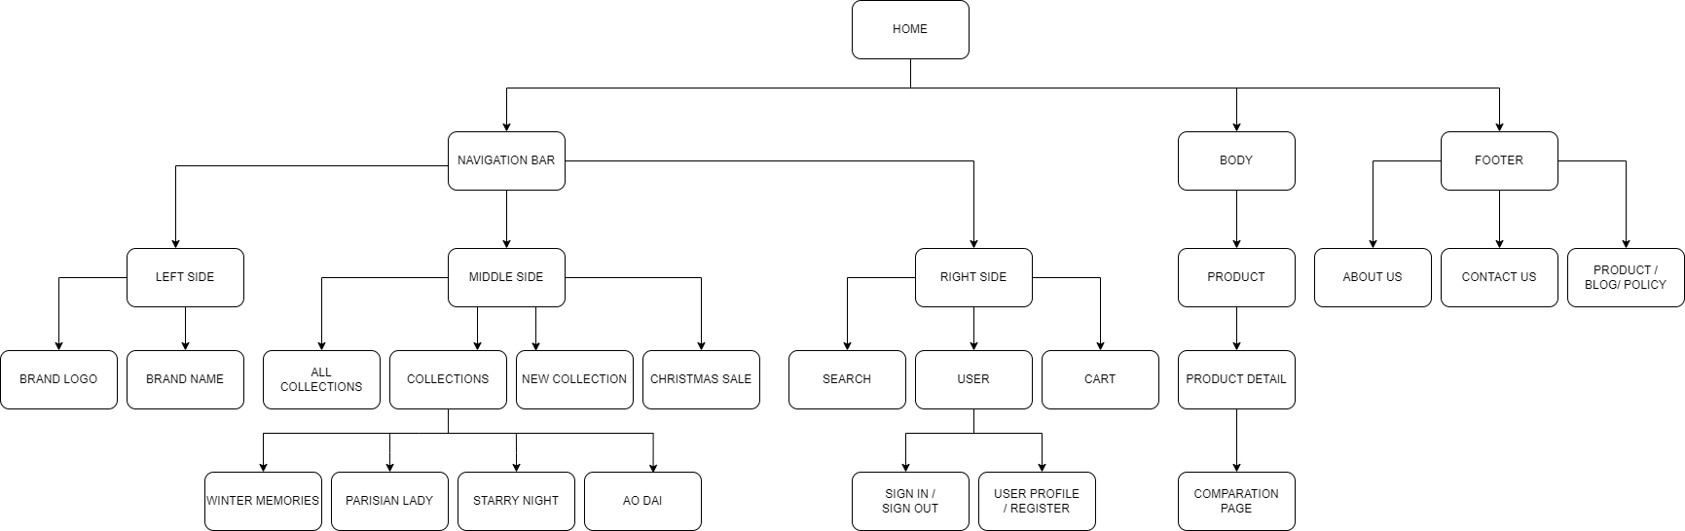

1. **Navigation Bar**



|  |  |  |  |  |
| --- | --- | --- | --- | --- |
| No | Name | Type | Action | Validation |
| 1 | Logo | Click | Navigate to Home |  |
| 2 | All Collections | Click | Navigate to All Products |  |
| 3 | Collections | on Mouse Enter Click | Show collections Navigate to a collection |  |
| 4 | New Collections | Click | Navigate to New Collections |  |
| 5 | Christmas Sale | Click | Navigate to on sale items |  |
| 6 | Search icon | Text | Search products by name |  |
| 7 | User Icon | on Mouse Enter Click | Show and navigate to Log in/Log out/Signup/Profile page |  |
| 8 | Cart Icon | Click | Navigate to Cart |  |

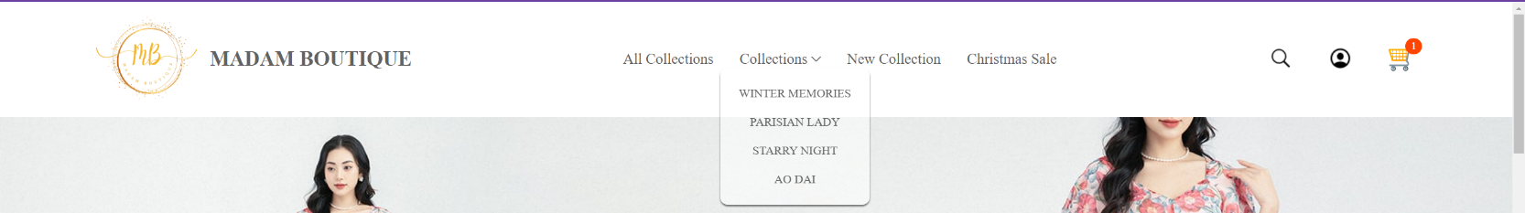

1. **Footer**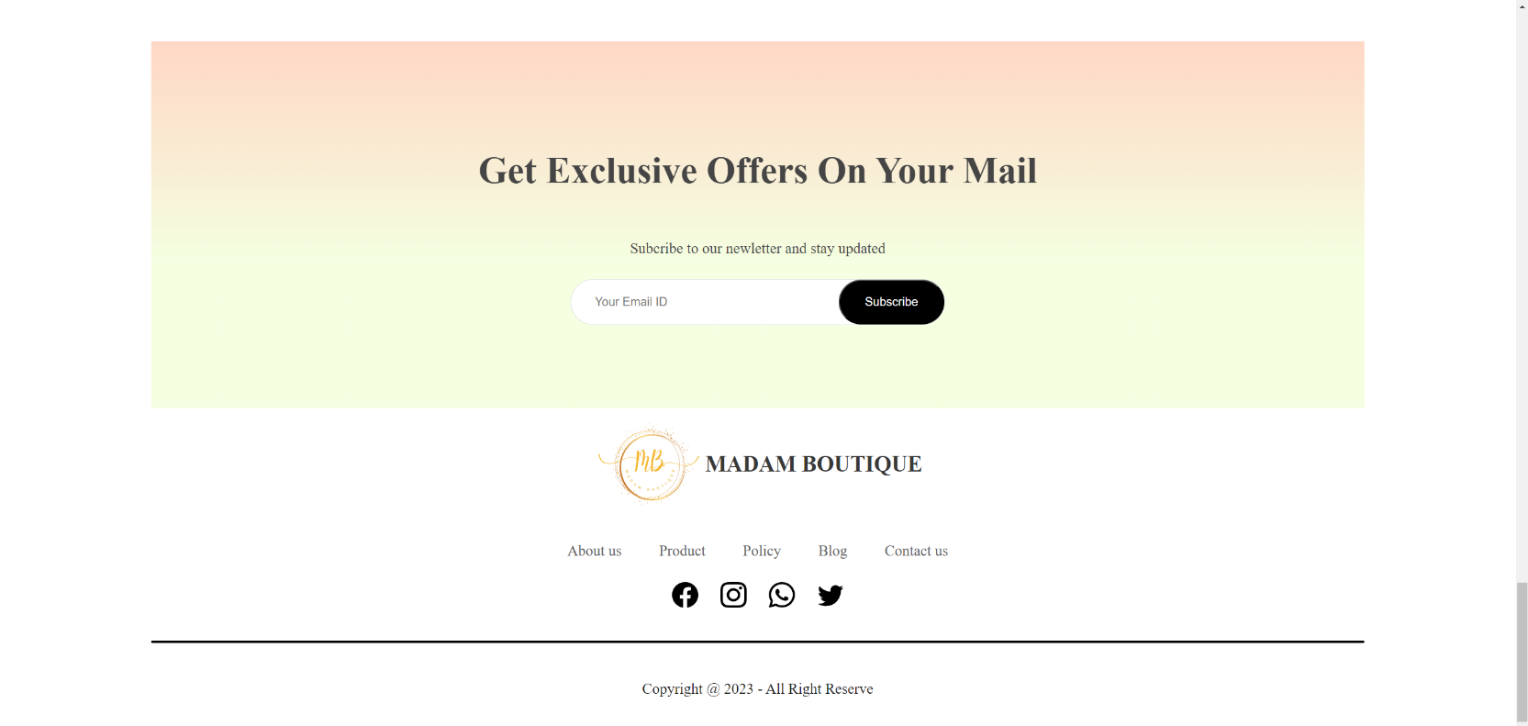

|  |  |  |  |  |
| --- | --- | --- | --- | --- |
| No | Name | Type | Action | Validation |
| 1 | Subscribe | Text | Subscribe email |  |
| 2 | Logo | Click | Navigate to Home |  |
| 3 | About us | Click | Navigate to About us |  |
| 4 | Product | Click | Navigate to About Product |  |
| 5 | Policy | Click | Navigate to Policy |  |
| 6 | Blog | Click | Navigate to Blogs page |  |
| 7 | Contact us | Click | Navigate to Contact us |  |
| 8 | Social app icon | Click | Link to social app page |  |
|  |  |  |  |  |

1. 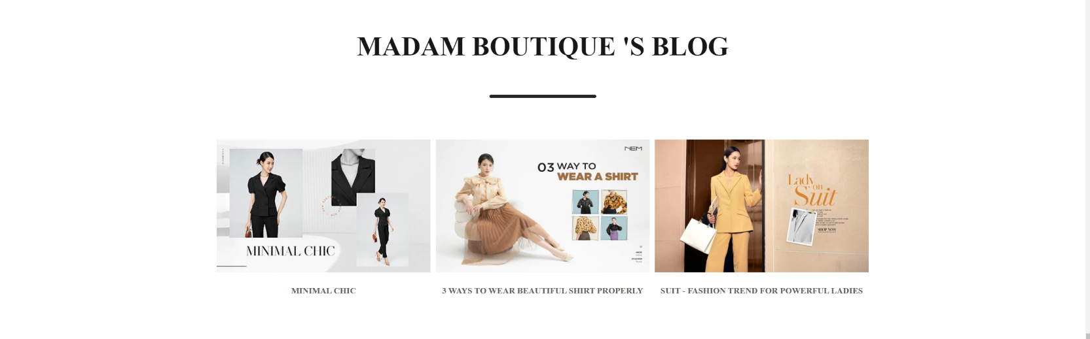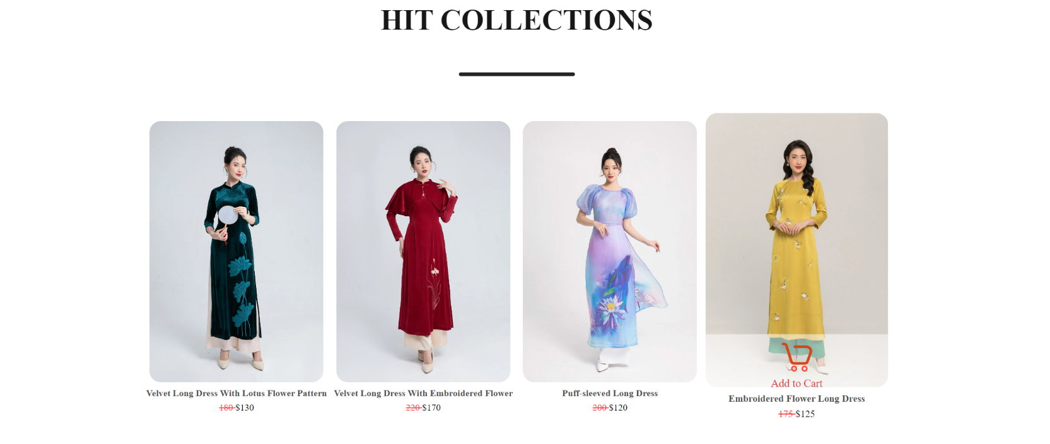**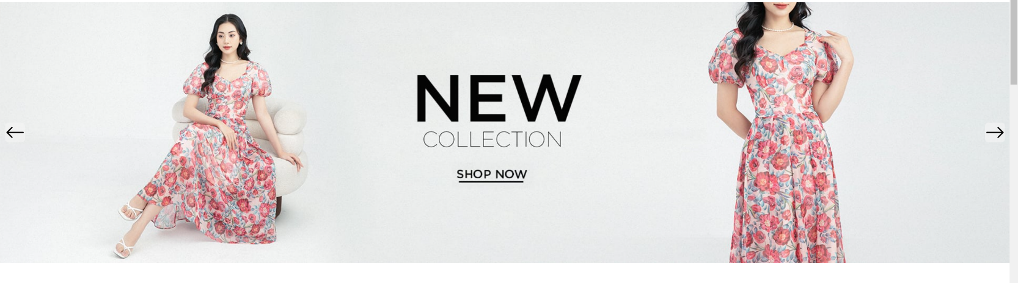Home page:**

|  |  |  |  |  |
| --- | --- | --- | --- | --- |
| No | Name | Type | Action | Validation |
| 1 | Slider | Click | Change slider images |  |
| 2 | Click on a slider picture | Click | Navigate to a collection |  |
| 3 | Click on a item image | Click | Navigate to product details |  |
| 4 | Cick on add to cart | Click | Add the item to cart |  |
| 5 | Click on a Blog Picture | Click | Navigate to a Blog |  |

1. **All products list:**

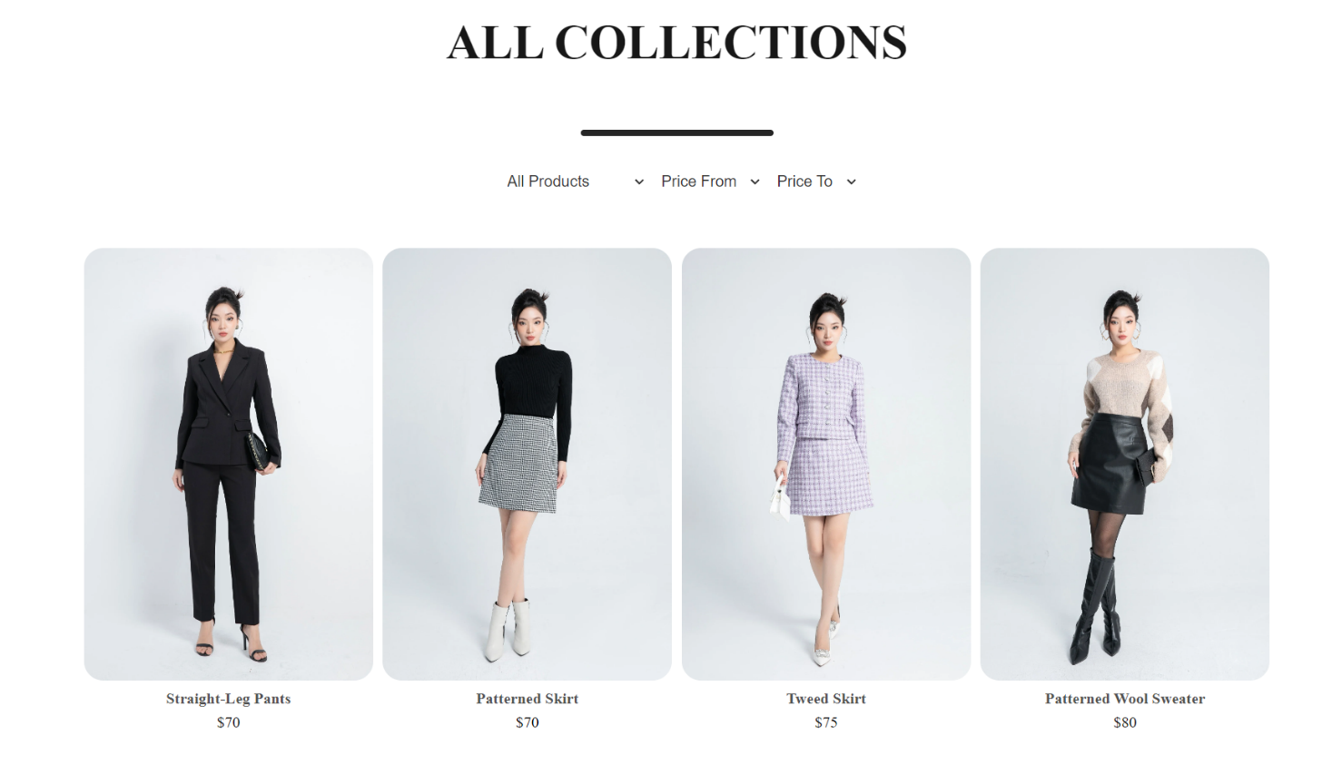

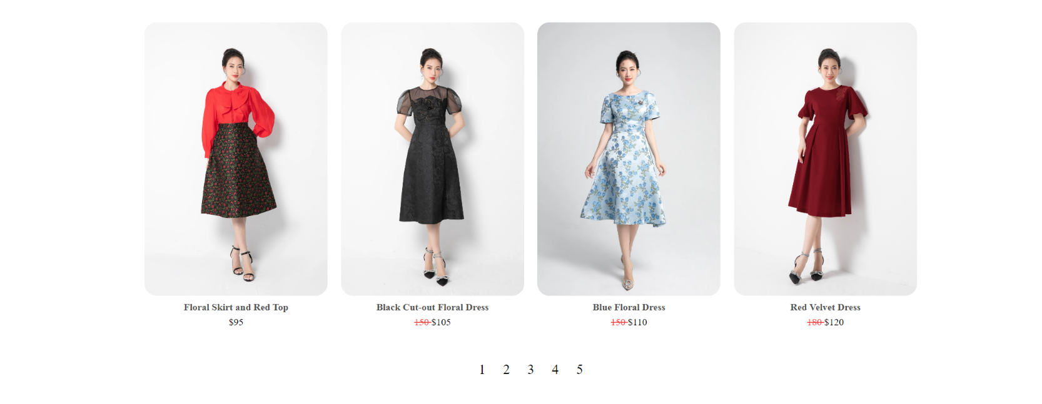

|  |  |  |  |  |
| --- | --- | --- | --- | --- |
| No | Name | Type | Action | Validation |
| 1 | Click on Search | Click | Multi-tag searching by type, min-price and max-price | Search by Type, minPrice, maxPrice |
| 2 | Click on a item image | Click | Navigate to product details |  |
| 3 | Cick on add to cart | Click | Add the item to cart |  |
| 4 | Pagination | Click | Change pages | Show max 8 items per page |

1. **Log in**

|  |  |  |  |  |
| --- | --- | --- | --- | --- |
| No | Name | Type | Action | Validation |
| 1 | Username | Text |  | Registered required |
| 2 | Password | Password |  | Registered required |
| 3 | Continue | Click | Check account - If seccess: Navigate to cart - If fail: Popup notification |  |
| 4 | Sign up | Click | Navigate to Sign up page |  |

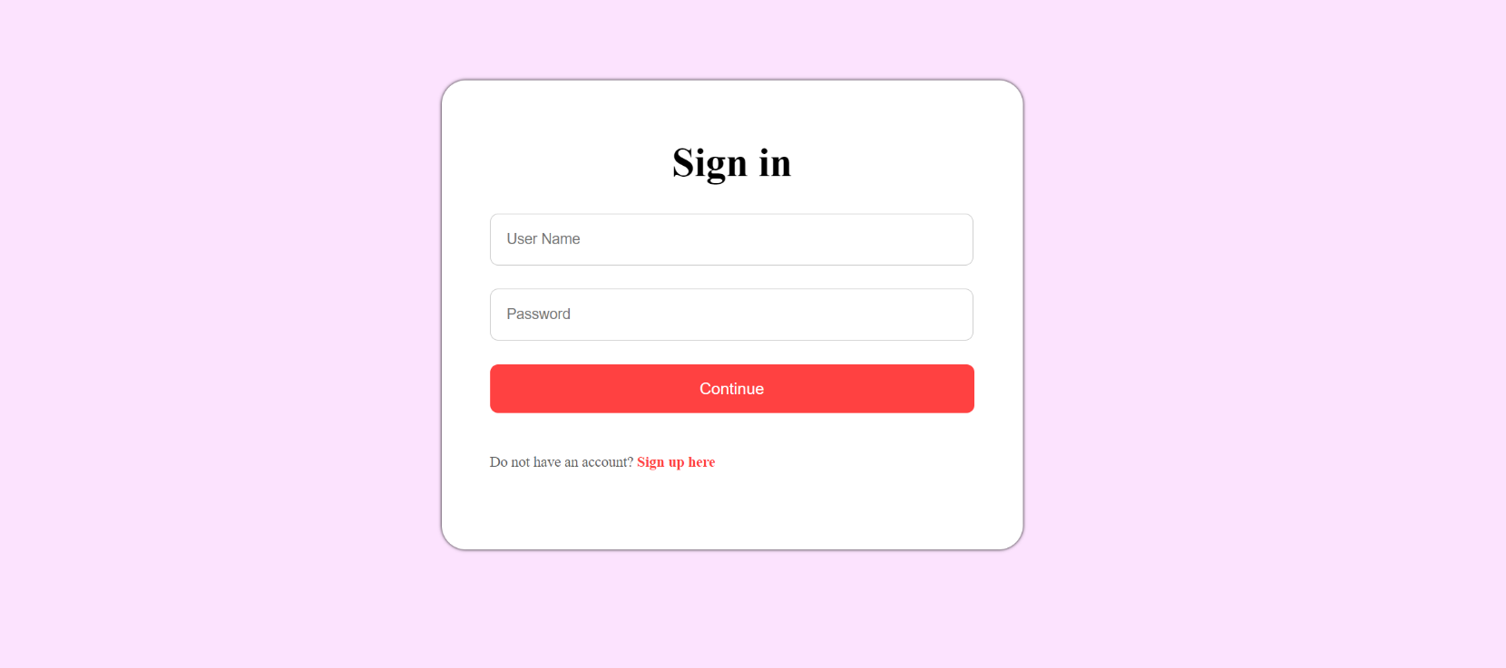

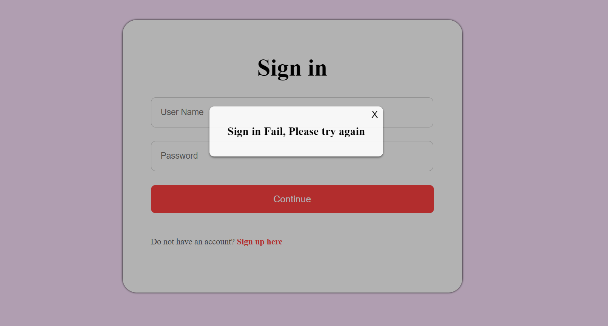

1. **Sign up**

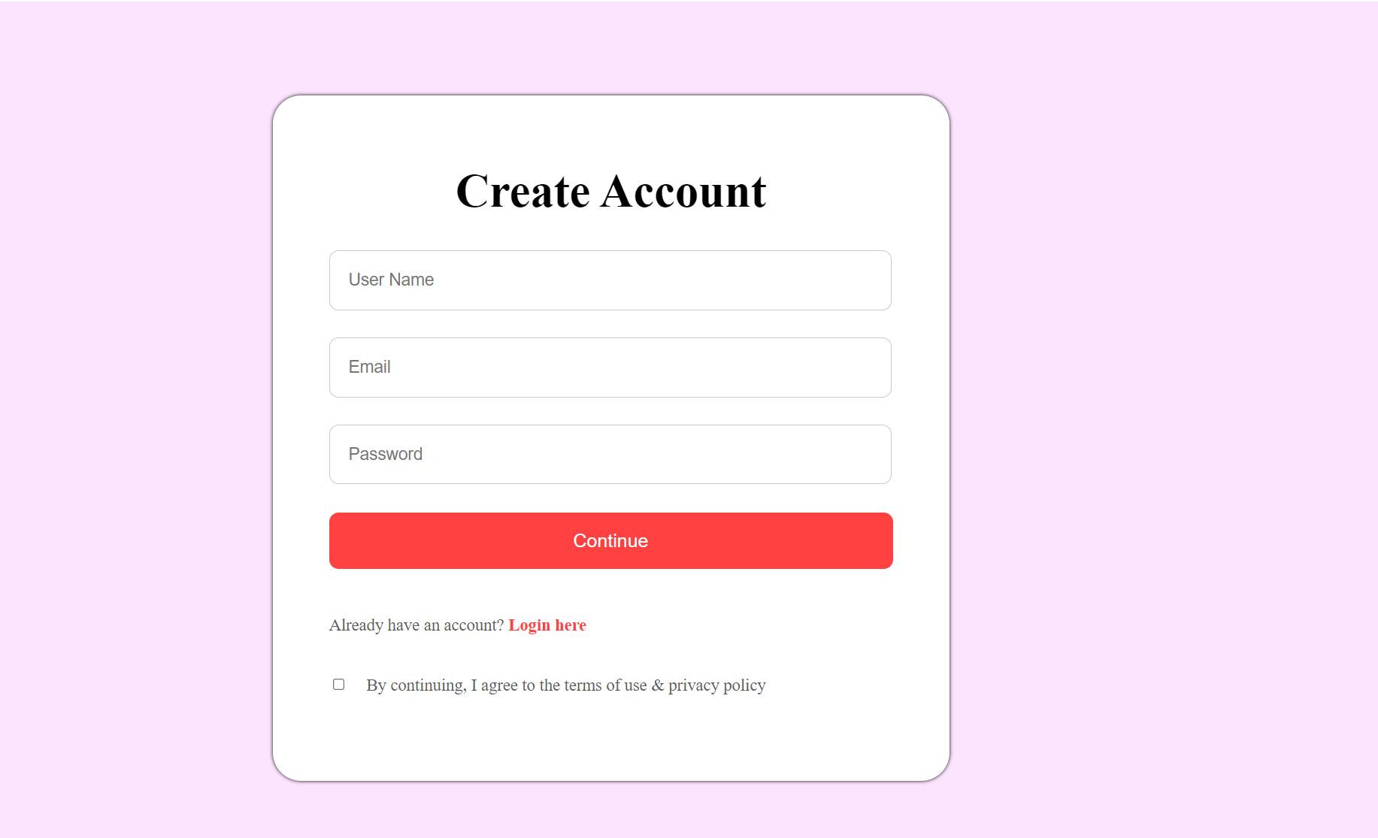

|  |  |  |  |  |
| --- | --- | --- | --- | --- |
| No | Name | Type | Action | Validation |
| 1 | Username | Text |  | No special character |
| 2 | Email | Email |  | Must be email format |
| 3 | Password | Password |  | Must not be empty |
| 4 | Continue | Click | Check username format Check email format Check password format Check Checkbox - If success: Navigate to Log in -If fail: Popup notification |  |
| 5 | Log-in | Click | Navigate to Log-in page |  |
| 6 | Checkbox | Checkbox |  | Must be checked |

1. **Cart Page**

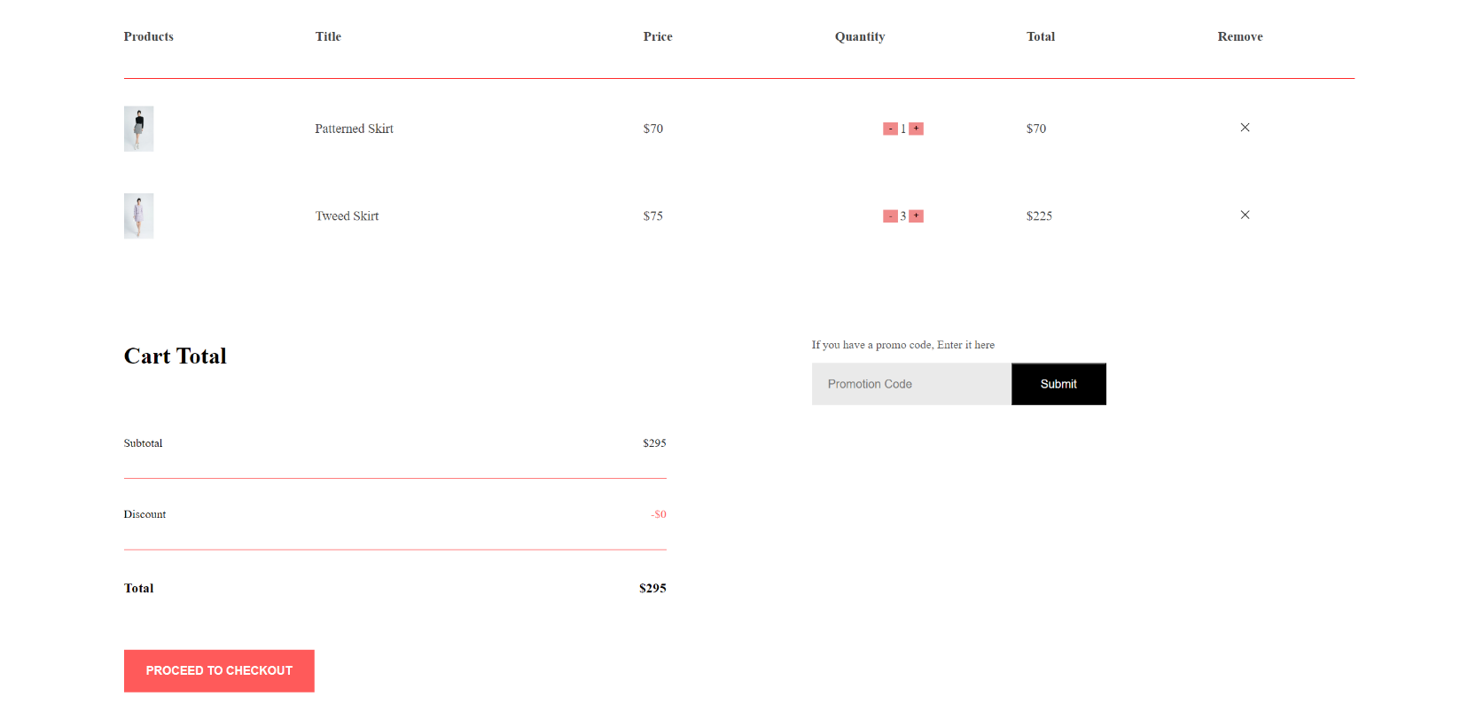

|  |  |  |  |  |
| --- | --- | --- | --- | --- |
| No | Name | Type | Action | Validation |
| 1 | icon + , - | Click | Increase/Decrese item quantity |  |
| 2 | icon x | Click | Remove an item from cart |  |
| 3 | Promo Code | Text | Enter Promo Code | Check valid code |
| 4 | Submit code | Click | Check Promo Code - If seccess: Applied to the Discount -If fail: Popup notification |  |
| 5 | Proceed to check out | Click | Check log in - If fail: Navigate to log in - If success: Navigate to Profile / Add cart items to user profile/ Remove item from cart | Log in required |

1. **Products Details Page:**

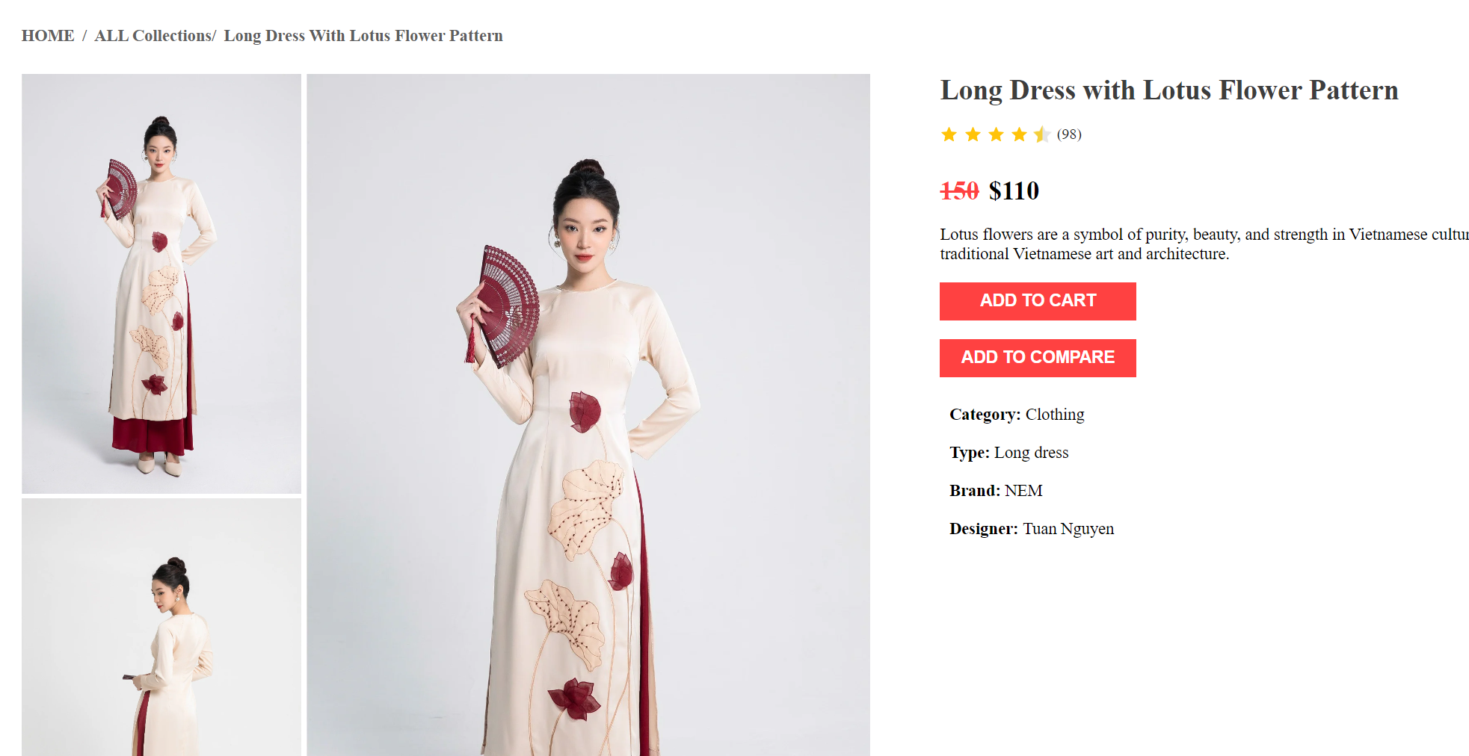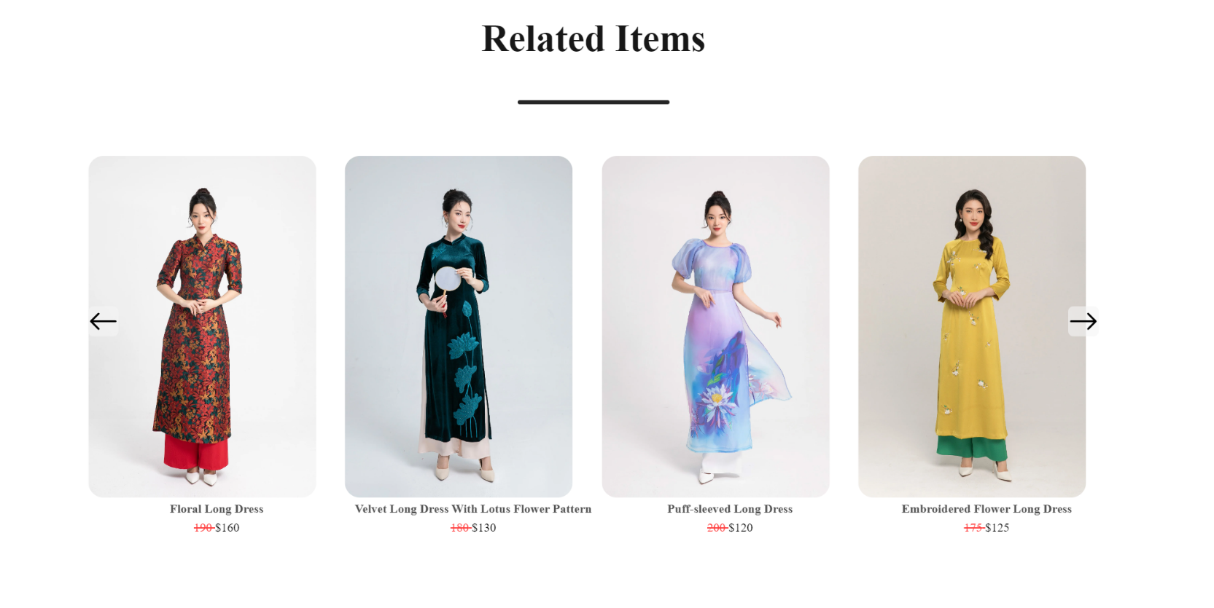

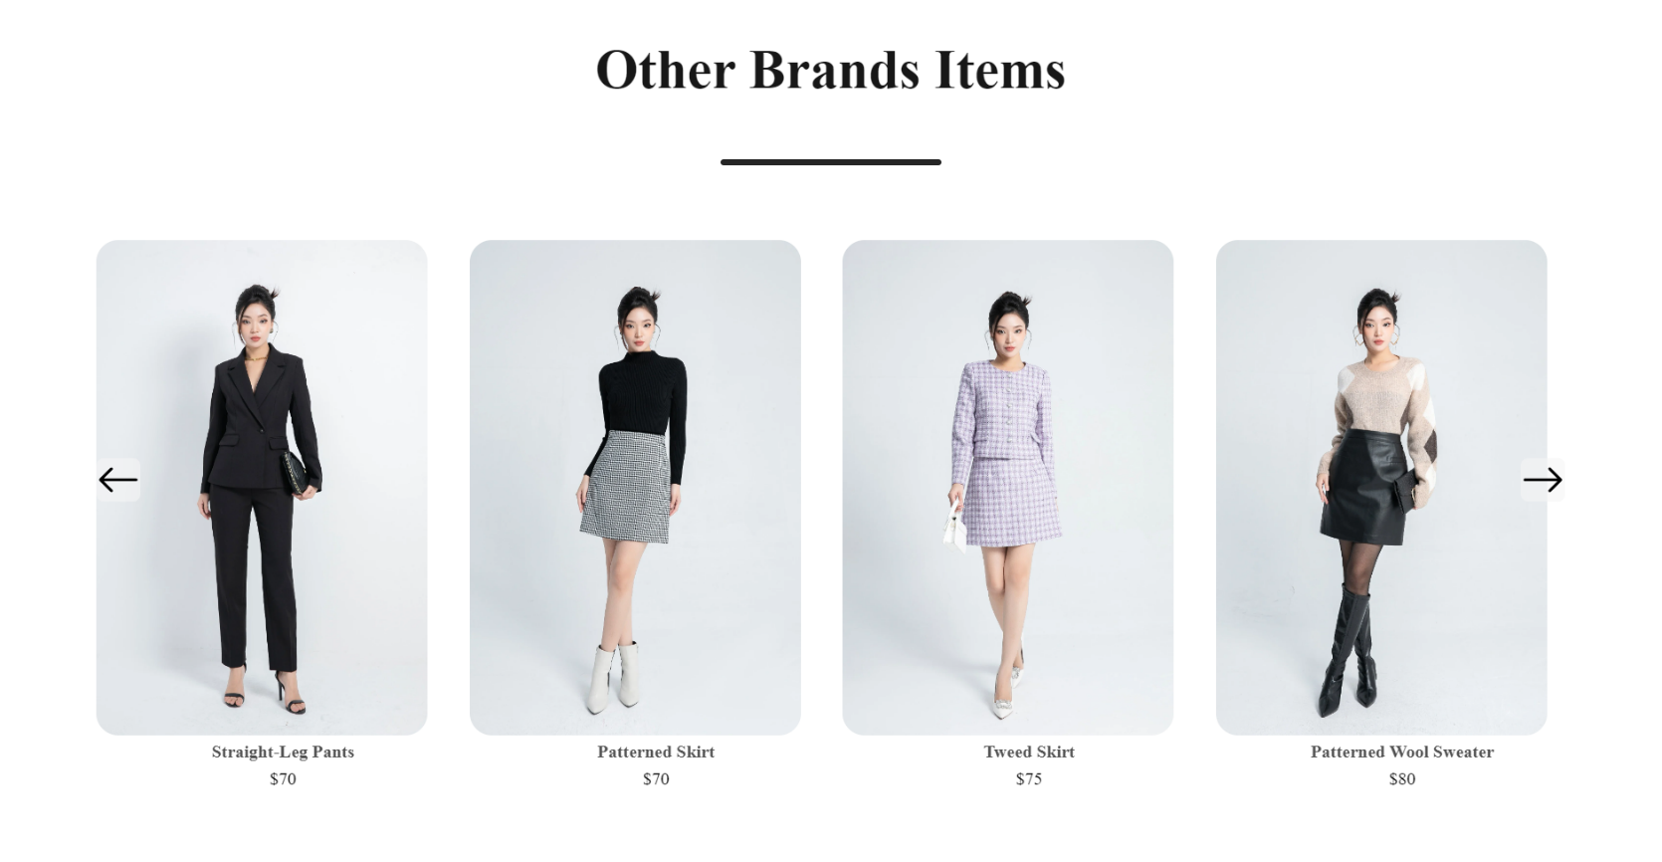

|  |  |  |  |  |
| --- | --- | --- | --- | --- |
| No | Name | Type | Action | Validation |
| 1 | Home | Click | Navigate to Home |  |
| 2 | All Collections | Click | Navigate to All Products |  |
| 3 | Change images | Click | Change image to show |  |
| 4 | Add to Compare | Click | Add item to compare Scroll to compare |  |
| 5 | Add to cart | Click | Add item to cart |  |

1. **Collections:**

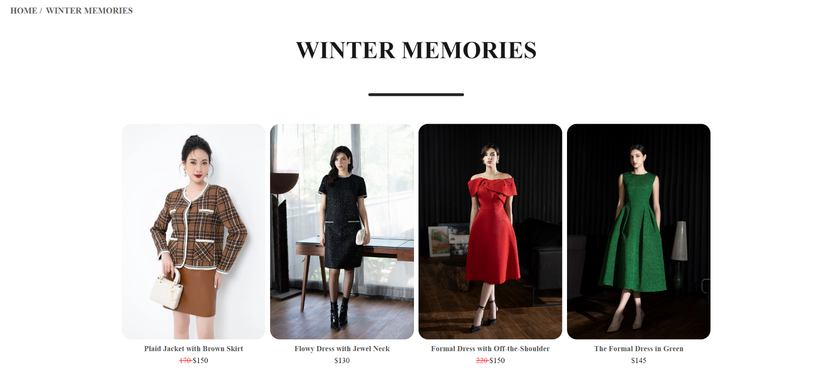

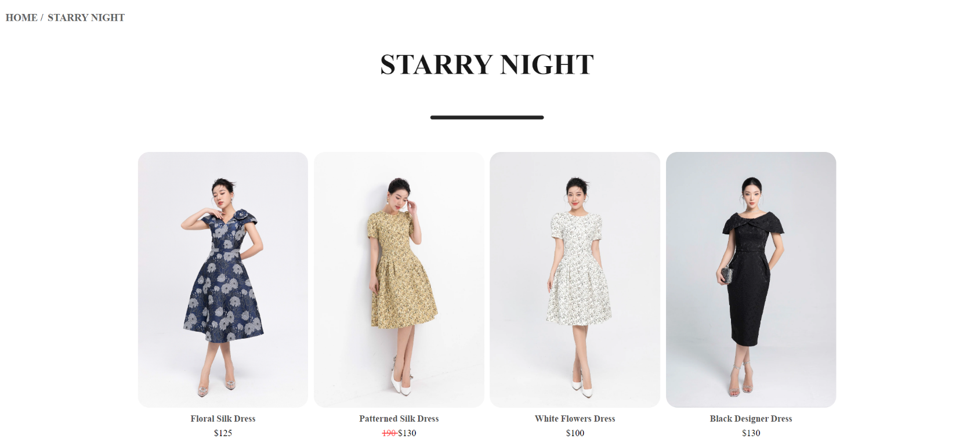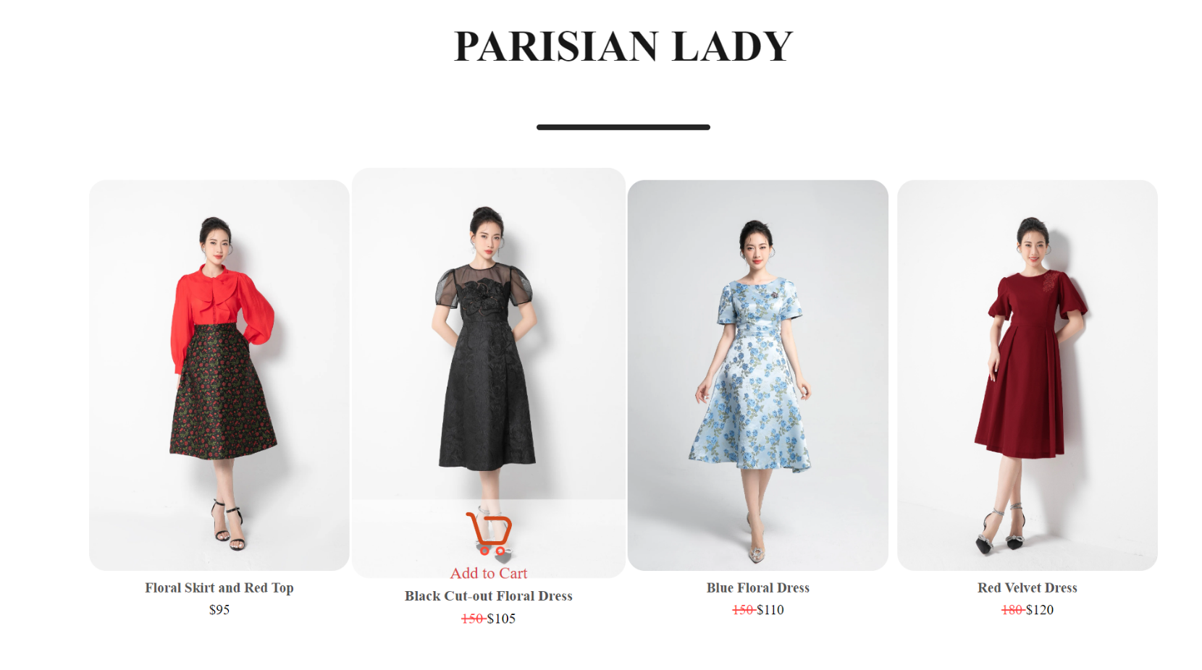

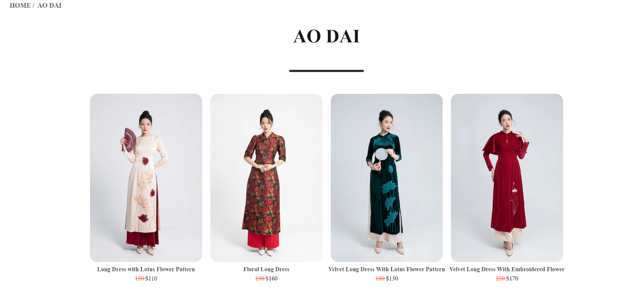

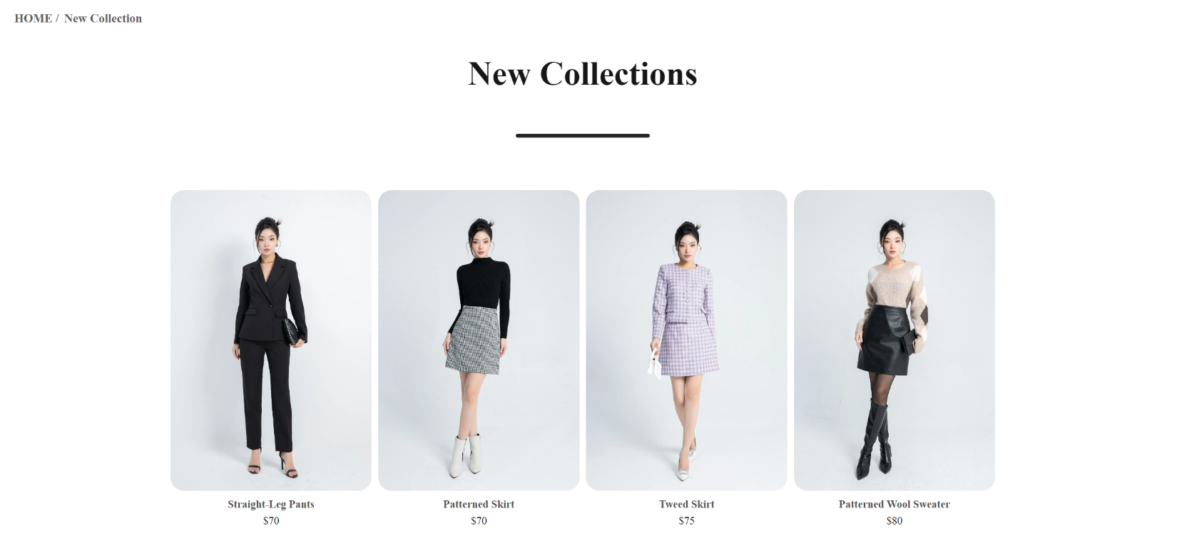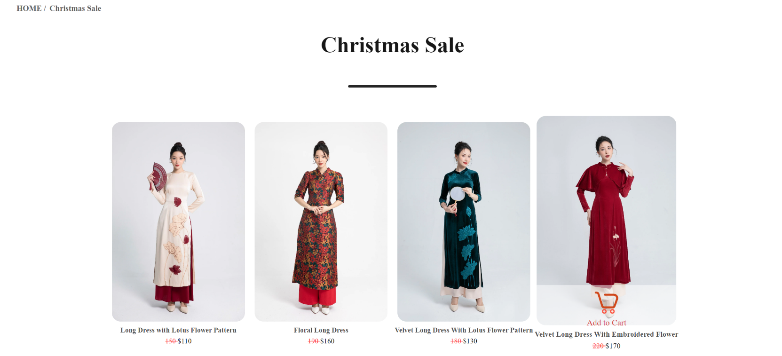

1. **Contact us:**
   * Contact us page using Geolocation

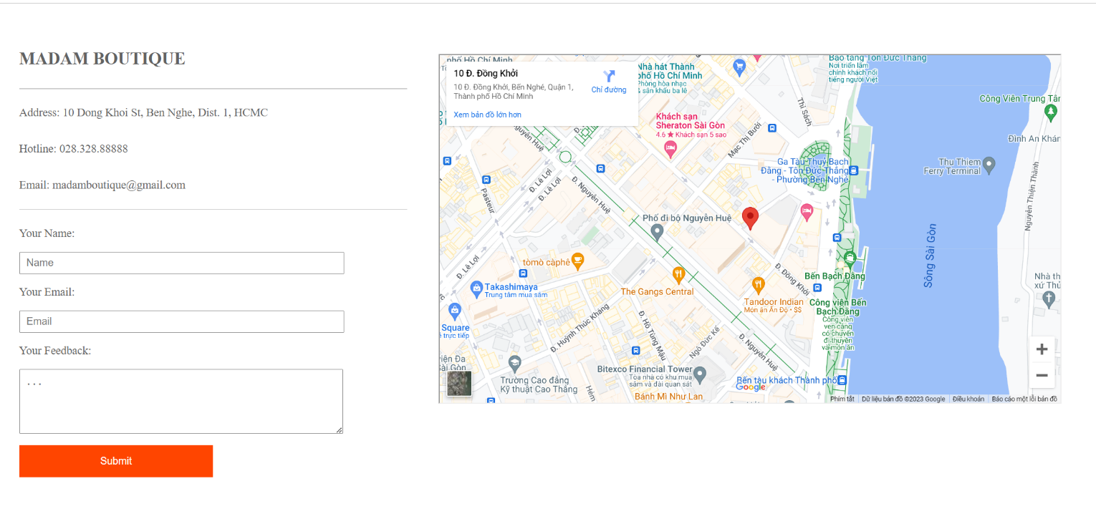

1. **User profile page:**
   * Show the user information and Item bought

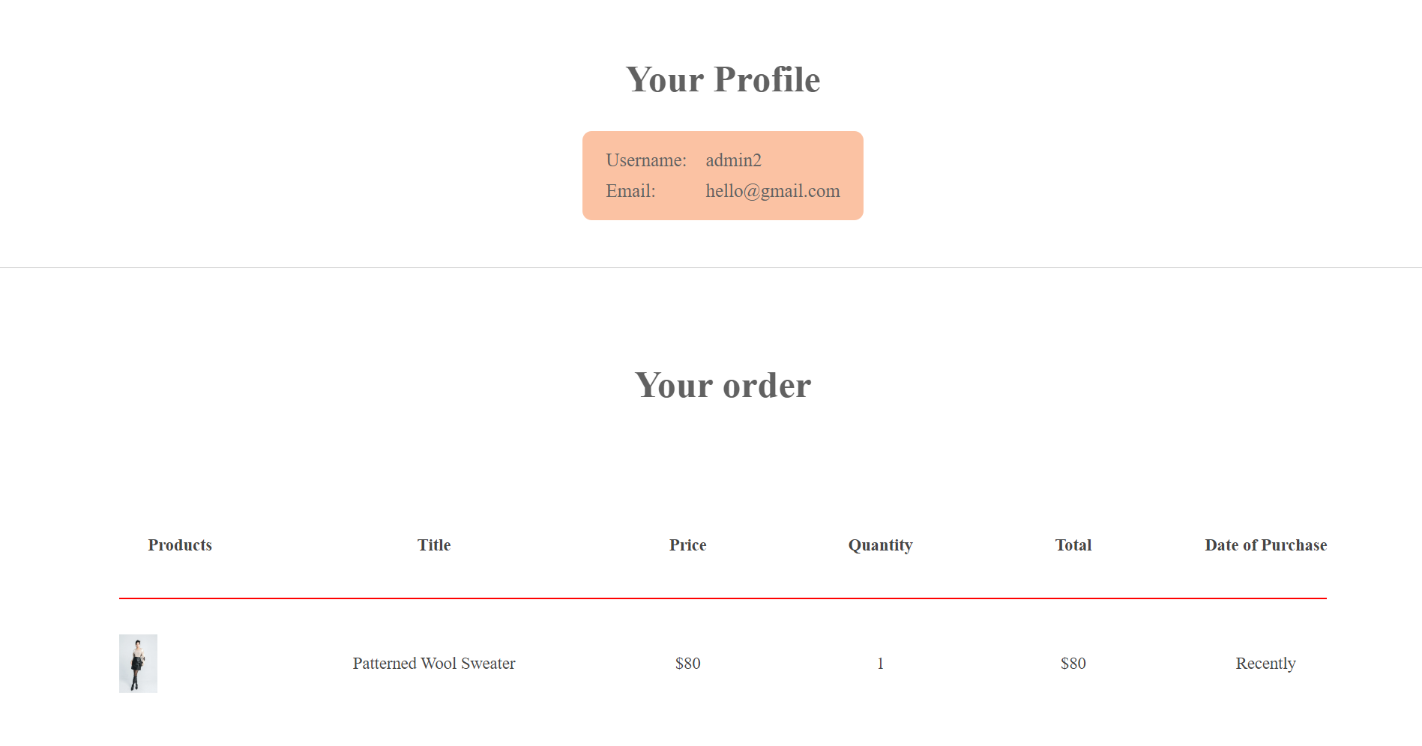

1. **Blogs:**

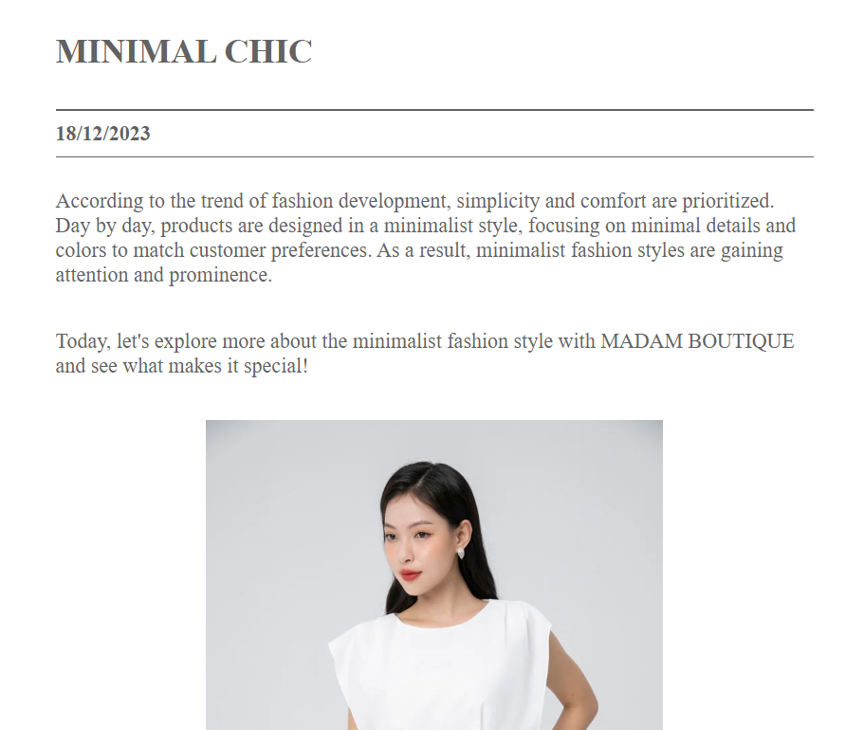

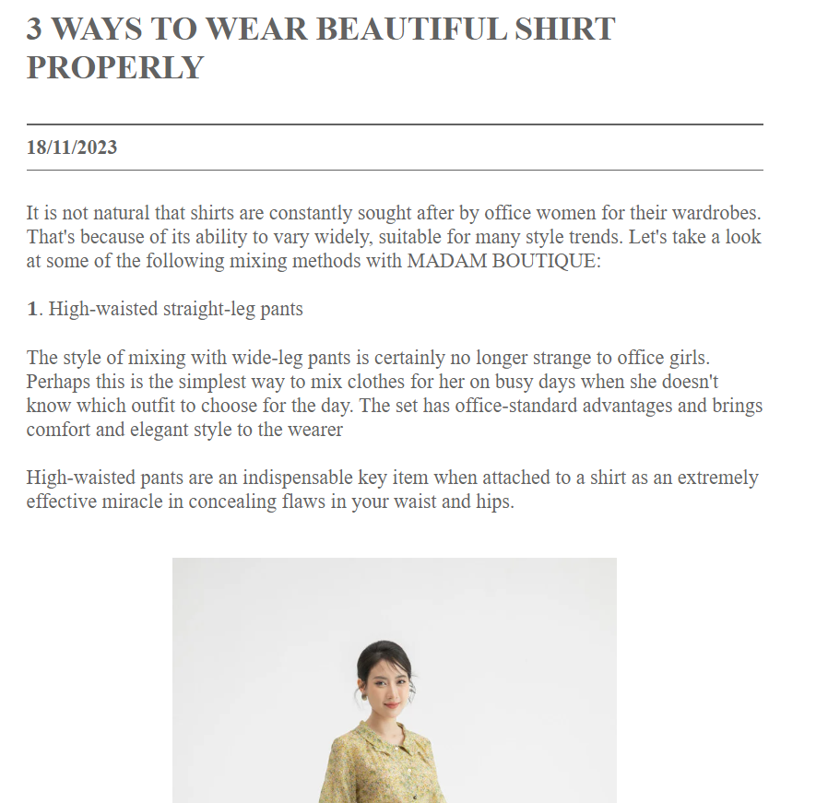

1. **About us, About Products, Policy:**

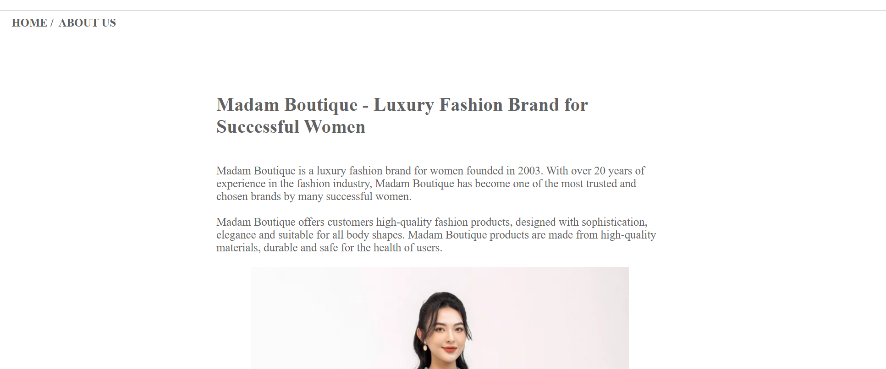

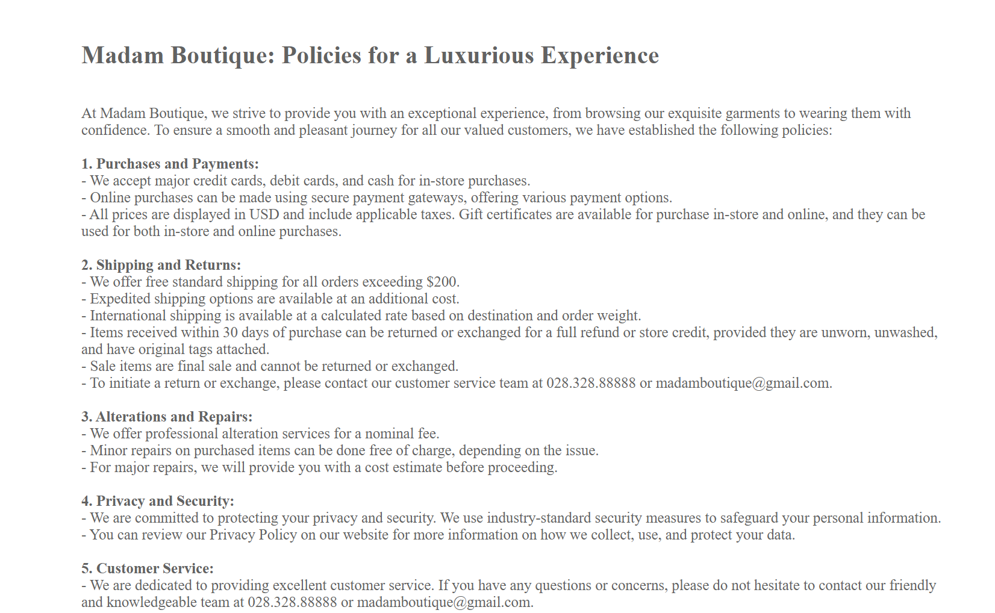



**TASK SHEET**

|  |  |  |  |  |  |  |  |
| --- | --- | --- | --- | --- | --- | --- | --- |
| No | Member | Contents | Page Name | Activity Plan | Date of Preparation of Activity Plan | | |
| Planed Start Date | Actual Start Date | Actual End Date | Status |
| 1 | Lê Anh Kiệt | Homepage | home.js | 24/11/2023 | 24/11/2023 | 24/12/2023 | 100% |
| All Collections Page | Productlist.js/  Collections… | 24/11/2023 | 24/11/2023 | 24/12/2023 | 100% |
| Product Details | Details.js  RelatedProducts.js  Comparation.js | 24/11/2023 | 24/11/2023 | 24/12/2023 | 100% |
| Nav-bar | NavBar.js | 24/11/2023 | 24/11/2023 | 24/12/2023 | 100% |
| Log-in / Sign-up | Login.js  Signup.js | 24/11/2023 | 24/11/2023 | 24/12/2023 | 100% |
| Cart | CartList.js  CartIem.js | 24/11/2023 | 24/11/2023 | 24/12/2023 | 100% |
| Footer | Footer.js | 24/11/2023 | 24/11/2023 | 24/12/2023 | 100% |
| Comparation | Comparation.js | 24/11/2023 | 24/11/2023 | 24/12/2023 | 100% |
| User Profile | Profile.js | 24/11/2023 | 24/11/2023 | 24/12/2023 | 100% |
| Blog | Blog.js | 24/11/2023 | 24/11/2023 | 24/12/2023 | 100% |
| About us | AboutUs.js | 24/11/2023 | 24/11/2023 | 24/12/2023 | 100% |
| Contact us | ContactUs.js | 24/11/2023 | 24/11/2023 | 24/12/2023 | 100% |
| Other page | Policy, About Product | 24/11/2023 | 24/11/2023 | 24/12/2023 | 100% |
| 2 | Huỳnh Trần Tân Viễn | Blog | Blog.js | 24/11/2023 | 24/11/2023 | 24/12/2023 | 0% |
| 3 | Vũ Hoàng Nam | About | About.js | 24/11/2023 | 24/11/2023 | 24/12/2023 | 0% |
| 4 | Phan Thanh Cường | Contact | Contact.js | 24/11/2023 | 24/11/2023 | 24/12/2023 | 0% |